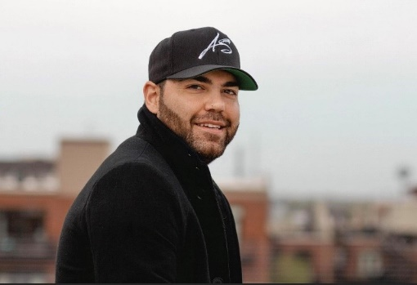

ANDREW SALGADO
www.andrewsalgado.NET
Biography

Andrew Salgado, who has been signed with Synapse Publishing & Entertainment®, LLC since 2017, came to prominence winning a national singer-songwriting competition and has penned songs for and with legends such as Brian Wilson, Darryl Worley, and Kacey Musgraves. He has opened for some of country music’s biggest icons such as Eli Young, Clint Black, and Toby Keith, released several well-received indie albums, and had his music featured in film and theatre.

The Nashville based recording artist who grew up in Chicago and migrated to Nashville nearly 10 years ago, released his third album, ‘86 VOL 2 – Autumn Dawn’ April 8th followed by a 2-month media tour, resulting in his first radio single, Lipstick Stains on my T-Shirt which ended up in the top 100 on the Music Row charts, spent 5 consecutive weeks at number one on the Roots Music Report Hot Country Songs chart, and ended up in regular rotation with 68 terrestrial radio stations and many internet and international radio spins. His vinyl record is now being sold in 10 record stores across the country and he is beginning to book his next major tour since the pandemic which is launching in 2023.

His latest radio single, launched several weeks ago is rapidly climbing the Music Row charts and was named the KBOW Buzz Cut it’s first week out. An accompanying video to the soulful ballad was also released.

Andrew is not a stranger to press and has been featured in multiple magazines, podcasts, TV, and radio and was featured for three years on the nationally aired PBS special “Songs at the Center” and has had appearances on WGN, ABC and NBC. Recently he has been a featured artist on specials such as Tom Tranchilla’s Songwriter Studio winning accolades for his writing and song production and being featured on the cover of Metronome Music magazine as well as others. For more about Andrew and to listen to his music visit https://www.linktr.ee/andrewsalgado.

ALBUM REVIEW QUOTE:
On his latest full-length album '86 Vol 2 - Autumn Dawn’, Nashville based indie singer, songwriter, and guitarist Andrew Salgado offers yet another spirited, eclectic showcase of his emotionally impactful vocals and dynamic country-pop driven style typified by the passionate, jangling rocker "Help Me" and the soulful, Latin influenced "Breathe." Releasing the album also as a 13-track vinyl LP and 15 track CD, the hard working, philanthropic artist is sure to delight current fans and capture the hearts of new followers with his genre busting originals.
Review by: Jonathan Widran, Writer The JW Vibe, Los Angeles

